IBM-Project-52658-1661062115

Classification of Arrhythmia by Using Deep Learning with 2-D ECG Spectral Image Representation

TEAM DETAILS:

Team ID: PNT2022TMID29524
College Name: Arunai Engineering College

Department: Electronics and Communication Engineering

TEAM MEMBERS:
- DHANUSHWARAN.S (TEAM LEADER)
- ARUN.B
- NAVEEN RAJ.S
- AKASH.A
TABLE OF CONTENT

S  NO | CONTENT | PAGE  NO
 | INTRODUCTION
 | Project Overview
 | Purpose
 | LITERATURE SURVEY
 | Existing problem
 | References
 | Problem Statement Definition
 | IDEATION & PROPOSED SOLUTION
 | Empathy Map Canvas
 | Ideation & Brainstorming
 | Proposed Solution
 | Problem Solution fit
 | REQUIREMENT ANALYSIS
 | Functional requirement
 | Non-Functional requirements
 | PROJECT DESIGN
 | Data Flow Diagrams
 | Solution & Technical Architecture

User Stories
PROJECT PLANNING & SCHEDULING
Sprint Planning & Estimation
Sprint Delivery Schedule
Reports from JIRA
CODING & SOLUTIONING (Explain the
features added in the project along with code)
Feature 1
Feature 2
Database Schema (if Applicable)
TESTING
Test Cases
User Acceptance Testing
RESULTS
Performance Metrics
ADVANTAGES & DISADVANTAGES
CONCLUSION
FUTURE SCOPE
APPENDIX
Source Code

GitHub & Project Demo Link

INTRODUCTION

PROJECT OVERVIEW:

According to the World Health Organization (WHO), cardiovascular diseases (CVDs) are the number one cause of death today. Over 17.7 million people died from CVDs in the year 2017 all over the world which is about 31% of all deaths, and over 75% of these deaths occur in low and middle-income countries. Arrhythmia is a representative type of CVD that refers to any irregular change from the normal heart rhythms. There are several types of arrhythmia including atrial fibrillation, premature contraction, ventricular fibrillation, and tachycardia.
Although a single arrhythmia heartbeat may not have a serious impact on life, continuous arrhythmia beats can result in fatal circumstances. In this project, we build an effective electrocardiogram (ECG) arrhythmia classification method using a convolutional neural network (CNN), in

which we classify ECG into seven categories, one being normal and the other six being different types of arrhythmia using deep two-dimensional CNN with grayscale ECG images. We are creating a web application where the user selects the image which is to be classified.

1.2PURPOSE:
An electrocardiogram (ECG) measures the electric activity of the heart and has been widely used for detecting heart diseases due to its simplicity and non-invasive nature. By analyzing the electrical signal of each heartbeat, i.e., the combination of action impulse waveforms produced by different specialized cardiac tissues found in the heart, it is possible to detect some of its abnormalitie.

2.LITERATURE SURVEY

EXISTING PROBLEM
Cardiovascular diseases (CVDs) are the number one cause of death today. Over 17.7 million people died from CVDs in the year 2017 all over the world which is about 31% of all deaths, and over 75% of these deaths occur in low and middle-income countries. Arrhythmia is a representative type of CVD that refers to any irregular change from the normal heart rhythms. There are several types of arrhythmias including atrial fibrillation, premature contraction, ventricular fibrillation, and tachycardia

REFERENCES Bibliography
    - https://www.sciencedirect.com/science/article/pii/S0169260715003314
- https://www.researchgate.net/publication/341623436_Classification_of_Arrhythmia_by_Using_Deep_Learning_with_2-D_ECG_Spectral_Image_Representation

  - PROBLEM STATEMENT DEFINITION

A heart arrhythmia (uh-RITH-me-uh) is an irregular heartbeat. Heart rhythm problems occur when the electrical signals that coordinates the heart’s beats don’t work properly. The faulty signaling causes the heart to beat too fast(tachycardia), too slow(bradycardia) or irregularly.

IDEATION & PROPOSED SOLUTION

EMPATHY MAP CANVAS
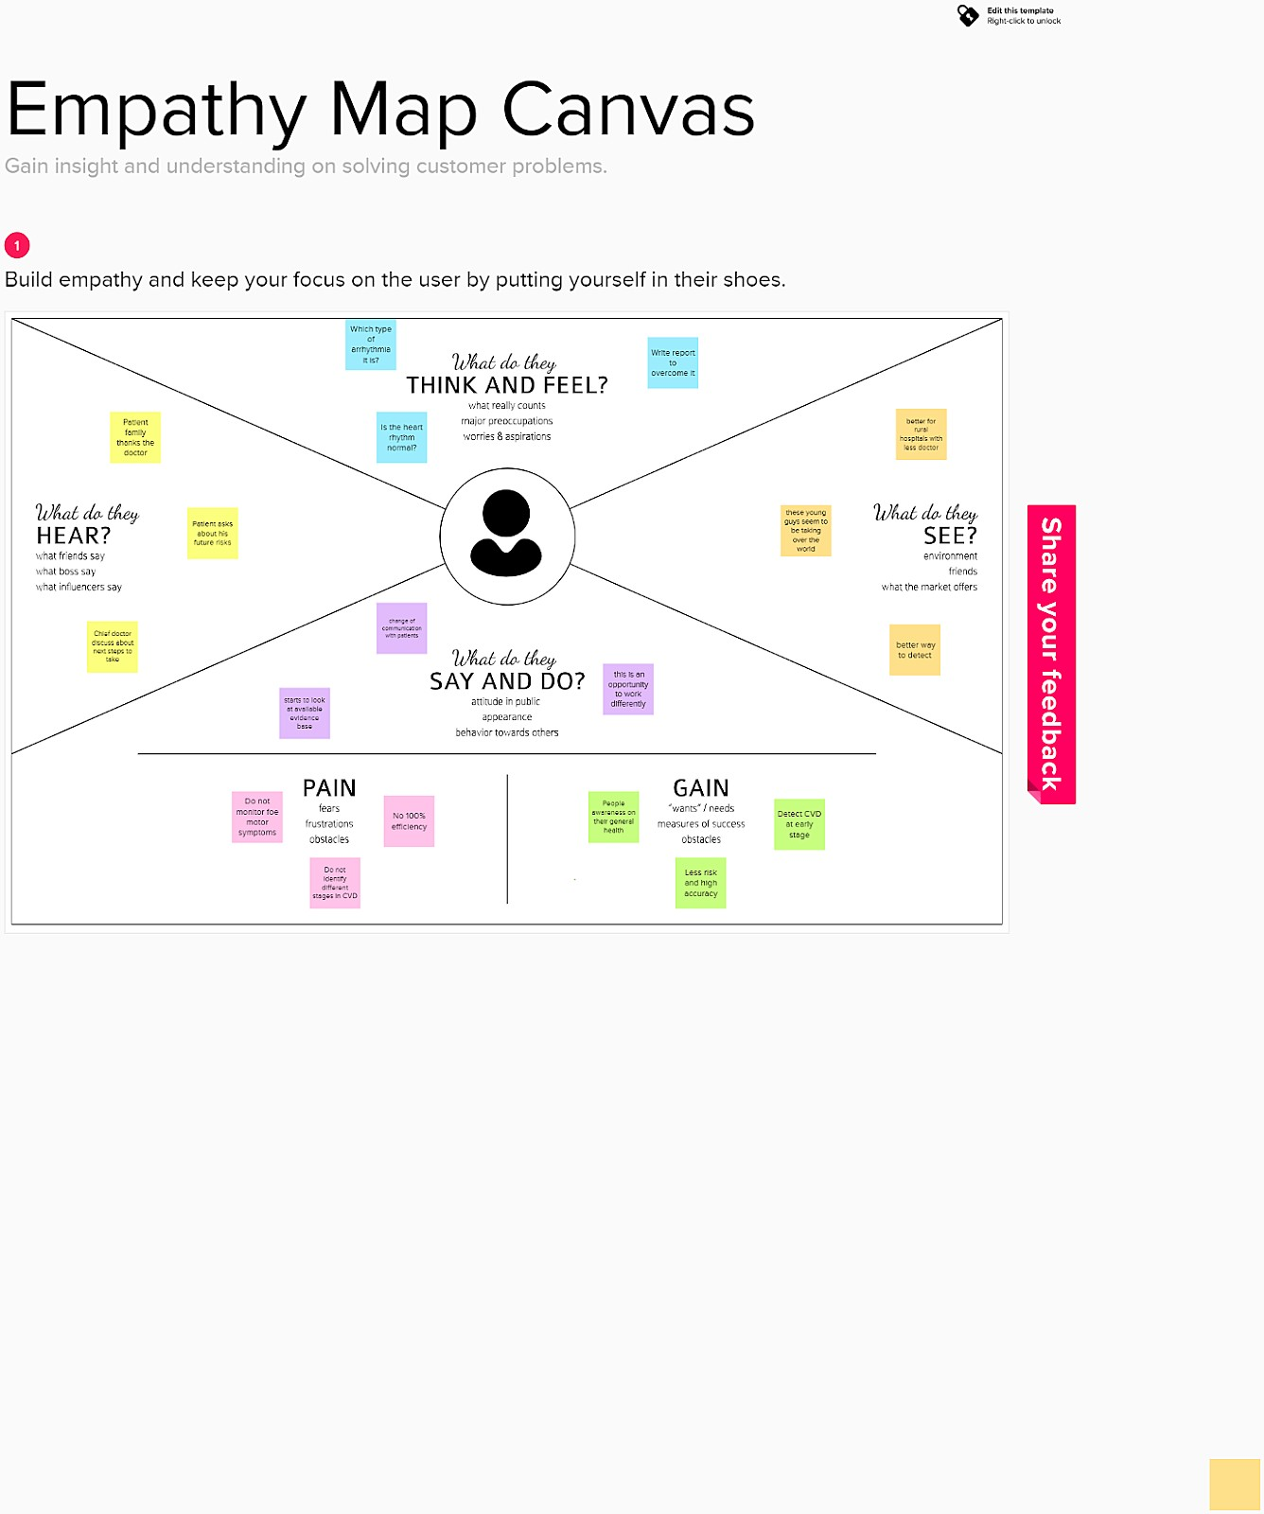

  - IDEATION AND BRAINSTORMING
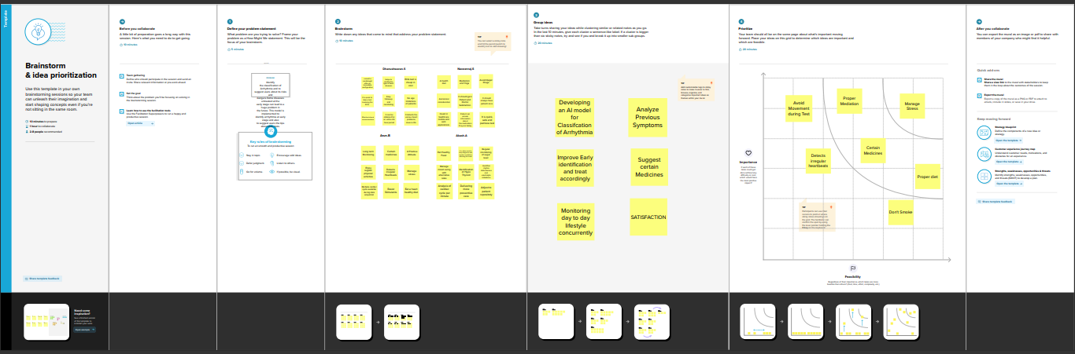

PROPOSED SOLUTION
An "ambulatory electrocardiogram" or an ECG) about the size of a postcard or digital camera that you'll use for 1 to 2 days, or up to 2 weeks. The test measures the movement of electrical signals or waves through your heart. These signals tell the heart to contract (squeeze) and pump blood. You'll have electrodes taped to your skin. It's painless, although some people have mild skin irritation from the tape used to attach the electrodes to the chest. You can do everything but shower or bathe while wearing the electrodes. After the test period, you'll go back to see your doctor. They'll download the information.

  - PROBLEM SOLUTION FIT

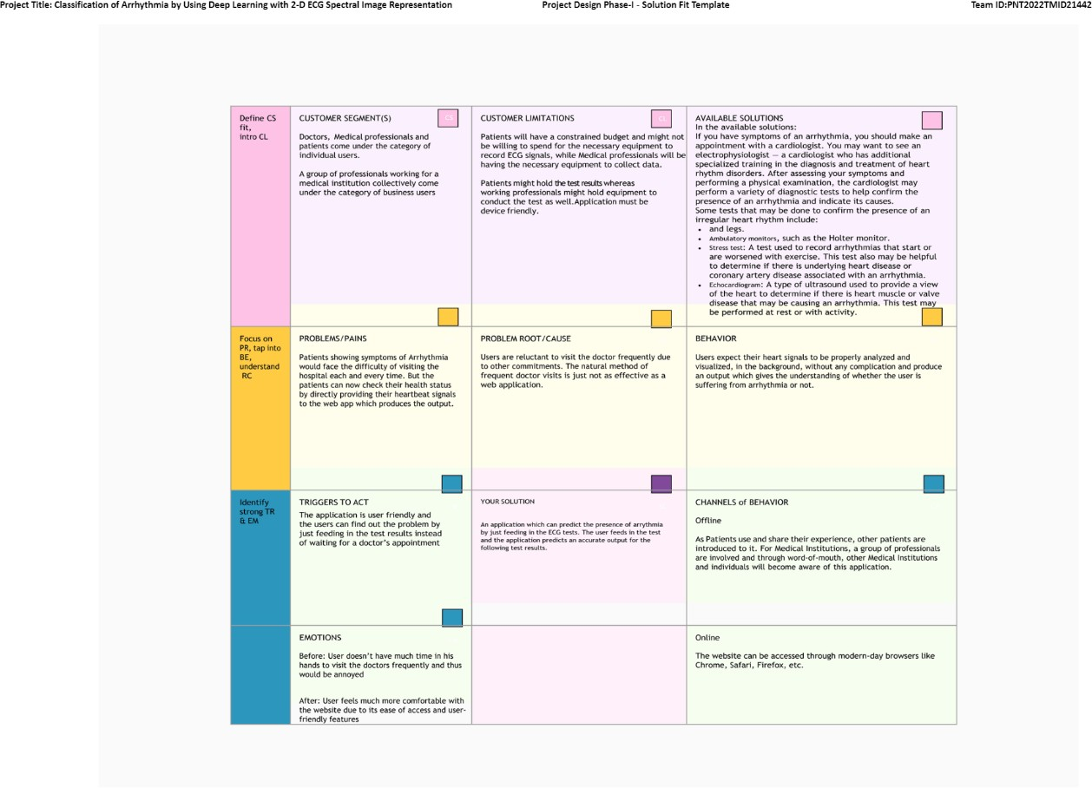

REQUIREMENT ANALYSIS

FUNCTIONAL REQUIREMENT
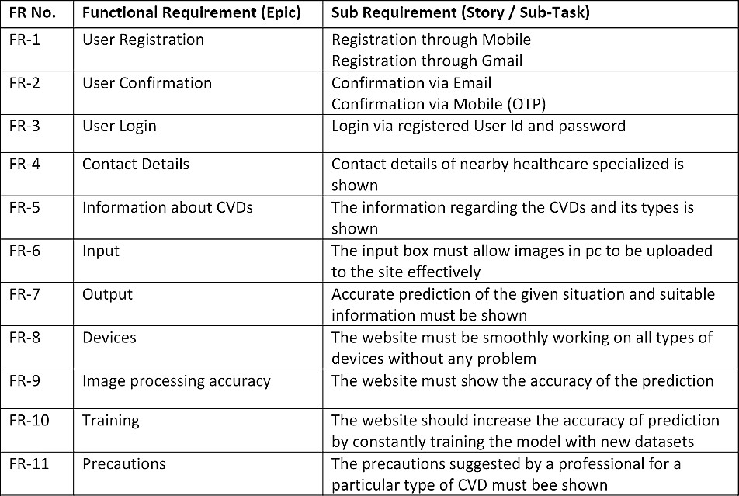

  - NON-FUNCTION REQUIREMENT
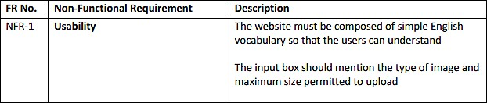

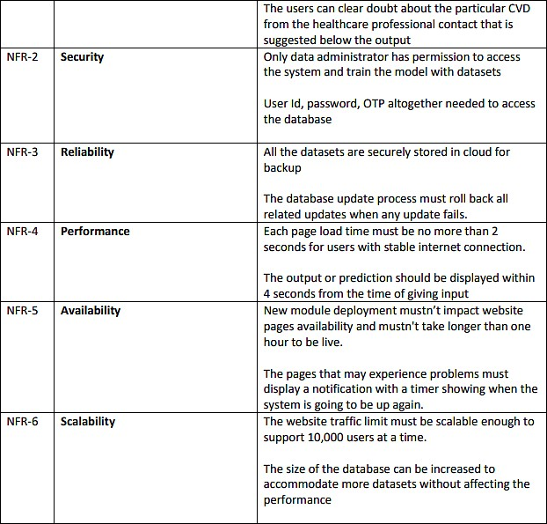

PROJECT DESIGN

DATA FLOW DIAGRAMS

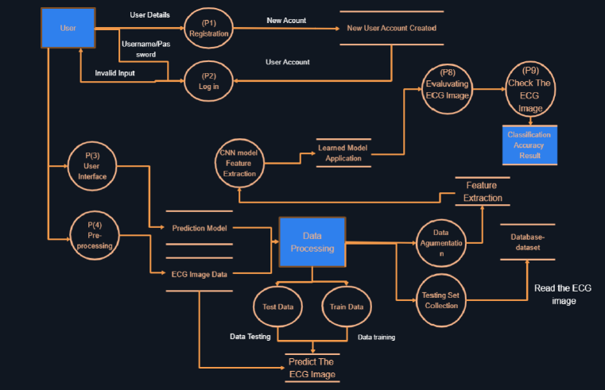

  - SOLUTION AND TECHNICAL ARCHITECTURE



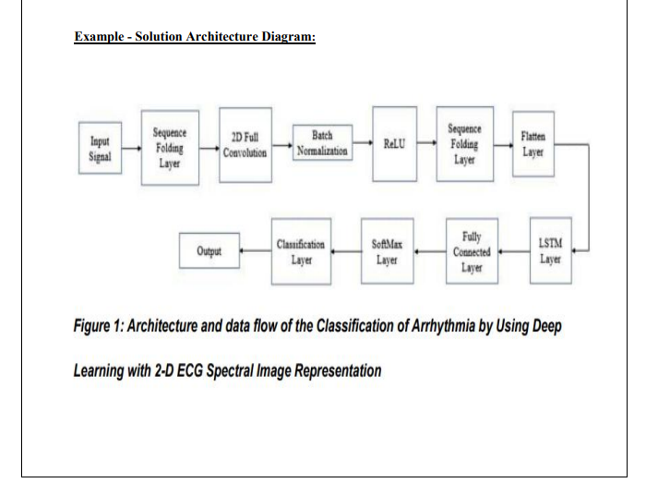

  - USER STORIES

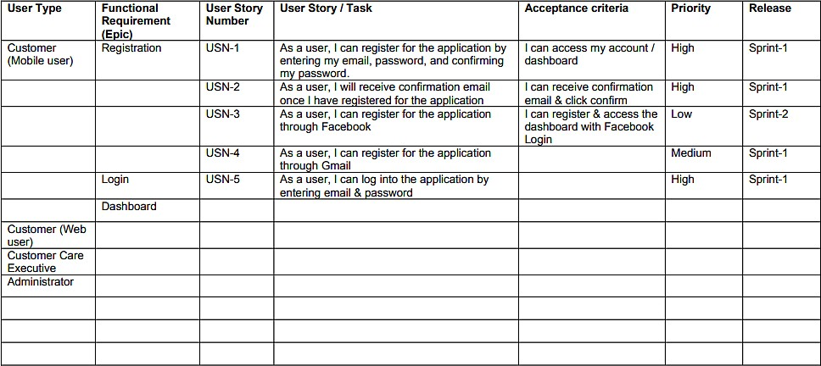

PROJECT PLANNING & SCHEDULING
‘Project Planning and Scheduling’, though separate, are two sides of the same coin in project management. Fundamentally, ‘Project planning’ is all about choosing and designing effective policies and methodologies to attain project objectives. While ‘Project scheduling’ is a procedure of assigning tasks to get them completed by allocating appropriate resources within an estimated budget and time-frame. The basis of project planning is the entire project. Unlikely, project scheduling focuses only on the project-related tasks, the project start/end dates and project dependencies. Thus, a ‘project plan’ is a comprehensive document that contains the project aims, scope, costing, risks, and schedule. And a project schedule includes the estimated dates and sequential project tasks to be executed. Project Planning The project planning phase refers to: ● Developing a project to make it ready for investment ● Determines the jobs/tasks required to attain project objectives

SPRINT PLANNING AND ESTIMATION What is sprint planning?
    - Sprint planning is an event in scrum that kicks off the sprint.
    - The purpose of sprint planning is to define what can be delivered in the sprint and how that work will be achieved.
    - Sprint planning is done in collaboration with the whole scrum team.
    - In scrum, the sprint is a set period of time where all the work is done.
    - However, before you can leap into action you have to set up the sprint.
    - You need to decide on how long the time box is going to be, the sprint goal, and where you're going to start.
    - The sprint planning session kicks off the sprint by setting the agenda and focus. If done correctly, it also creates an environment where the team is motivated, challenged, and can be successful.
    - Bad sprint plans can derail the team by setting unrealistic expectations

SPRINT DELIVERY SCHEDULE
Sprint-1
    - Download The Dataset
    - Import ImageDataGenerator Library
    - Configure ImageDataGenerator class
    - Import Libraries
    - IInitialize the Model
Sprint-2
    - Register IBM Cloud
    - Apply ImageDataGeneratorfu functionality to Trainset and Dataset
    - Test the mode Sprint-3
    - Train the model on IBM
    - Create Html files 2022
    - Train the Model Sprint–4
    - Configure The Learning Process
    - Build Python code
    - Adding Dense Layer
    - Adding CNN laye

REPORTS FROM JIRA

Jira's value proposition heavily relies on its reporting capabilities. By delivering critical insights in real time, reporting elevates the value of your Jira deployment and empowers your team to take informed decisions that improve output and performance. It is crucial to evaluate each project's status in order to accomplish objectives and control workloads. Jira reports can aid teams in quickly identifying and resolving performance, bandwidth, and
workflow obstacles, enabling them to stay on top of both short- term and long-term projects.
It's crucial to note that Jira provides a variety of tools and reports to assist you in getting a clear picture of your team's progress, each with unique advantages, restrictions, and applications. Each team or organisation should utilise the reports and resources that
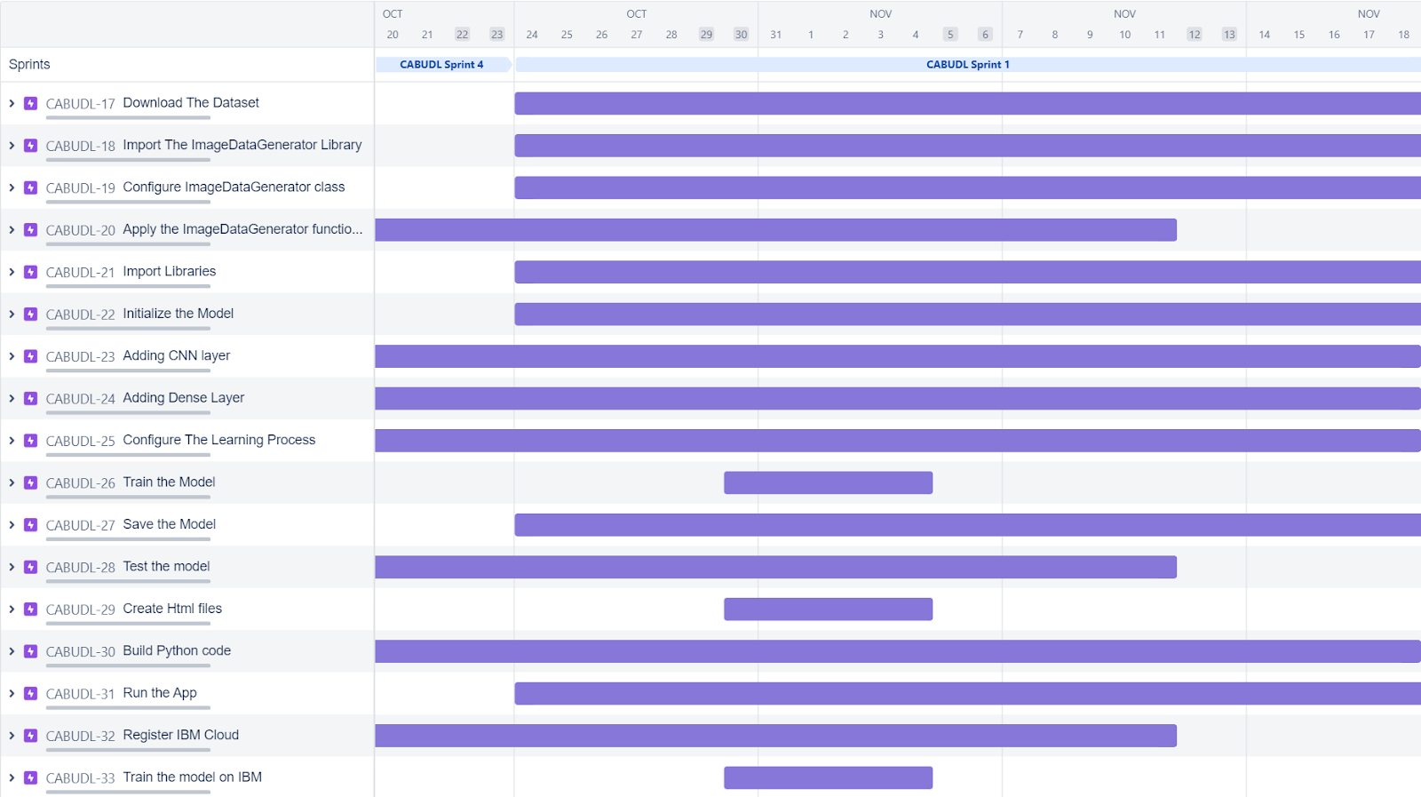

CODING & SOLUTION
College graduates with prior programming expertise or technical degrees are recruited and transitioned into professional positions with Alabama firms and organisations through the highly competitive CodingSolutions job accelerator and talent refinement programme at no cost to the graduates. We provide a pool of varied, well-trained, techs-savvy individuals that wants to launch and advance their career in Alabama.
The mission of veteran- and woman-owned CodingSolutions is to mobilise the next generation of IT talent and provide them the tools and resources they require to make your business successful. Innovative talent is necessary for innovative technologies. We wish to provide CodingSolutions prospects to assist you expand your Alabama team.
Our applicants are swiftly hired at the top of the list by growing businesses for lucrative, long-term positions.

FEATURES
- User interacts with User interface to upload image
- Uploaded image is analyzed by the model which is integrated
- Once model analyses the uploaded image, the prediction is showcased on the UI

TESTING
The purpose of testing is to discover errors. Testing is the process of trying to discover every conceivable fault or weakness in a work product. It provides a way to check the functionality of components, sub-assemblies, assemblies and/or a finished product It is the process of exercising software with the intent of ensuring that the Software system meets its requirements and user expectations and does not fail in an unacceptable manner. There are various types of test. Each test type addresses a specific testing requirement.

TYPES OF TESTS
    - Unit testing
Unit testing involves the design of test cases that validate that the internal program logic is functioning properly, and that program inputs produce valid outputs. All decision branches and internal code flow should be validated. It is the testing of individual software units of the application .it is done after the completion of an individual unit before integration. This is a structural testing, that relies on knowledge of its construction and is invasive. Unit tests perform basic tests at component level and test a specific business process, application, and/or system configuration. Unit tests ensure that each unique path of a business process performs accurately to the documented specifications and contains clearly defined inputs and expected results.

Integration testing
Integration tests are designed to test integrated software components to determine if they actually run as one program. Testing is event driven and is more concerned with the basic outcome of screens or fields. Integration tests demonstrate that although the components were individually satisfaction, as shown by successfully unit testing, the combination of components is correct and consistent. Integration testing is specifically aimed at exposing the problems that arise from the combination of components.

Functional test
Functional tests provide systematic demonstrations that functions tested are available as specified by the business and technical requirements, system documentation, and user manuals. Functional testing is centered on the following items: Valid Input : identified classes of valid input must be accepted. Invalid Input : identified classes of invalid input must be rejected. Functions : identified functions must be exercised. Output : identified classes of application outputs must be exercised. Systems/Procedures: interfacing systems or procedures must be invoked. Organization and preparation of functional tests is focused on requirements, key functions, or special test cases. In addition, systematic coverage pertaining to identify Business process flows; data fields, predefined processes, and successive processes must be considered for testing. Before functional testing is complete, additional tests are identified and the effective value of current tests is determined.

System Test
System testing ensures that the entire integrated software system meets requirements. It tests a configuration to ensure known and predictable results. An example of system testing is the configuration-oriented system integration test. System testing is based on process descriptions and flows, emphasizing pre-driven process links and integration points.

White Box Testing
White Box Testing is a testing in which in which the software tester has knowledge of the inner workings, structure and language of the software, or at least its purpose. It is purpose. It is used to test areas that cannot be reached from a black box level.

Black Box Testing
Black Box Testing is testing the software without any knowledge of the inner workings, structure or language of the module being tested. Black box tests, as most other kinds of tests, must be written from a definitive source document, such as specification or requirements document, such as specification or requirements document. It is a testing in which the software under test is treated, as a black box .you cannot “see” into it. The test provides inputs and responds to outputs without considering how the software works.

Unit Testing:
Unit testing is usually conducted as part of a combined code and
unit test phase of the software lifecycle, although it is not uncommon for coding and unit testing to be conducted as two distinct phases.

Test strategy and approach
Field testing will be performed manually and functional tests will be written in detail.

Test objectives
- All field entries must work properly.
- Pages must be activated from the identified link.
- The entry screen, messages and responses must not be delayed.

Features to be tested
- Verify that the entries are of the correct format
- No duplicate entries should be allowed
- All links should take the user to the correct page.

Integration Testing
Software integration testing is the incremental integration testing of two or more integrated software components on a single platform to produce failures caused by interface defects. The task of the integration test is to check that components or software applications, e.g. components in a software system or – one step up – software applications at the company level – interact without error. Test Results: All the test cases mentioned above passed
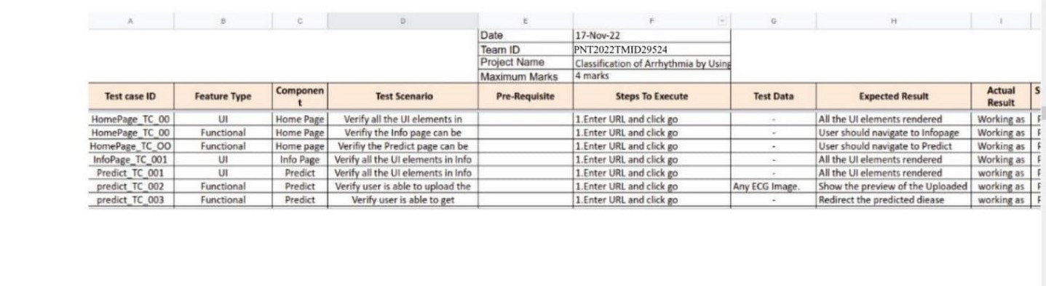
successfully. No defects encountered.
 | Test Scenarios
1 | Verify user is able to see Home page
2 | Verify user is able to navigate Info Page
3 | Verify user is able to navigate Predict Page
4 | Verify user is able to see Info page
5 | Verify user is able to see Predict page
6 | Verify user is able to upload ECG image

Acceptance Testing
User Acceptance Testing is a critical phase of any project and requires significant participation by the end user. It also ensures that the system meets the functional requirements. Test Results: All the test cases mentioned above passed successfully. No defects,encountered.

7 | Verify user is able to redirect to predicted result page

RESULTS

PERFORMANCE METRICS
Training Accuracy - 97.84 Validation Accuracy - 85.08

ADVANTAGES & DISADVANTAGES

- High accuracy
- High sensitivity
- High reliability
- Reduced loss
- Do not monitor motor response
- Do not identify different stages in CVD

CONCLUSION

In this study, we proposed a 2-D CNN-based classication model for automatic classicationof cardiac arrhythmias using ECG signals. An accurate taxonomy of ECG signals is extremelyhelpful in the prevention and diagnosis of CVDs. Deep CNN has proven useful in enhancing theaccuracy of diagnosis algorithms in the fusion of medicine and modern machine learning technologies.The proposed CNN-based classication algorithm, using 2-D images, can classify eight kinds ofarrhythmia, namely,
NOR, VFW, PVC, VEB, RBB, LBB, PAB, and APC, and it
achieved 97.91% averagesensitivity, 99.61% specicity, 99.11% average accuracy, and 98.59% positive predictive value (precision).These results indicate that the prediction and classication of arrhythmia with 2-D ECG representationas spectrograms and the CNN model is a reliable operative technique in the diagnosis of CVDs.The proposed scheme can help experts diagnose CVDs by referring to the automated classication of
Remote Sens. 2020,12, 1685 12 of 14ECG signals. The present research uses only a single-lead ECG signal. The effect of multiple lead ECGdata to further improve experimental cases will be studied in future work

FUTURE SCOPE
Automatic heartbeat classification is essential for real-time applications in detection of cardiac arrhythmias. Programmed heartbeat order is basic for continuous applications in the location of cardiovascular arrhythmias. The acquired consequences of this proposal recommend that there is a potential development of future in programmed ECG order frameworks. The frameworks must incorporate four conclusive advances: pre-handling, QRS complex discovery, highlights extraction and order of pulses. The further exertion of this work should move towards proposing new component extraction and arrangement strategies.
The future is using this detection of cardiac arrhythmia tools in wearable devices so that they could continuously
monitor the health of the person and send alerts when there is an abnormality. We additionally recommend the utilization of new patterns to catch the ECG signal, for example,
off-the-individual methodologies, for the elaboration of new databases. In any case, we accept that the making of such databases would be an extraordinary test in light of the fact
that, other than the money related costs included, they would need to be consolidated into gauges, for example, AAMI measures to contact the ideal crowd.

APPENDIX

SOURCE CODE

MODEL TRAINING:

- Data Collection

pwd

!pip install keras
!pip install tensorﬂow

import keras keras. version

import tensorﬂow

In [ ]:

In [ ]:

In [ ]:

In [ ]:
tensorﬂow. version
Loading our data

import os, types
import pandas as pd
from botocore.client import Conﬁg
import ibm_boto3

def iter (self): return 0

In [ ]:

# @hidden_cell
# The following code accesses a ﬁle in your IBM Cloud Object Storage. It includes your credentials.
# You might want to remove those credentials before you share the notebook.
cos_client = ibm_boto3.client(service_name='s3', ibm_api_key_id='dlfSXsHrHx9xly751DrA5r13Jmo2sWxk76JXeII4pi2N', ibm_auth_endpoint="https://iam.cloud.ibm.com/oidc/token", conﬁg=Conﬁg(signature_version='oauth'), endpoint_url='https://s3.private.us.cloud-object-
storage.appdomain.cloud')

bucket = 'classiﬁcationofarrhythmiabyusing-donotdelete-pr-7j5j6vzxaehedv' object_key = 'data.zip'

streaming_body_2 = cos_client.get_object(Bucket=bucket, Key=object_key)['Body']

# Your data ﬁle was loaded into a botocore.response.StreamingBody object. # Please read the documentation of ibm_boto3 and pandas to learn more about the possibilities to load the data.
# ibm_boto3 documentation: https://ibm.github.io/ibm-cos-sdk-python/ # pandas documentation: http://pandas.pydata.org/

from io import BytesIO
import zipﬁle
unzip = zipﬁle.ZipFile(BytesIO(streaming_body_2.read()),'r') ﬁle_paths=unzip.namelist()
print(ﬁle_paths)
for path in ﬁle_paths: unzip.extract(path)
In [ ]:

In [ ]:
pwd
- Image Preprocessing

Import The Image data Generator

from keras.preprocessing.image import ImageDataGenerator

#setting parameter for Image bata agumentation to the traing data train_datagen= ImageDataGenerator(rescale=1./255, shear_range=0.2, zoom_range=0.2, horizontal_ﬂip=True)

#Image Data agumentation to the testing data test_datagen = ImageDataGenerator(rescale=1./255) Apply Image Data Generator Functionality To Trainset and Testset

#performing data agumentation to train data
x_train = train_datagen.ﬂow_from_directory(directory =

In [ ]:

In [ ]:
"/home/wsuser/work/data/train", target_size = (64, 64), batch_size = 32, class_mode='categorical')

#performing data agumentation to test data
x_test = test_datagen.ﬂow_from_directory(directory = "/home/wsuser/work/data/test" , target_size = (64, 64), batch_size = 32, class_mode="categorical")
Conﬁqure Image Data Generator Class

x_train.class_indices

Model Buliding

Adding Layers:

#Import req. Lib.
from tensorﬂow.keras.models import Sequential
In [ ]:

In [ ]:
from tensorﬂow.keras.layers import Convolution2D, MaxPooling2D, Flatten,
Dense
# Build a CNN Block:
model = Sequential() #intializing sequential model model.add(Convolution2D(32,(3,3),activation='relu', input_shape=(64,64,3))) #convolution laye model.add(MaxPooling2D(pool_size=(2, 2))) #Maxpooling layer
model.add(Flatten()) #Flatten layer model.add(Dense(400,activation='relu')) #Hidden Layer 1 model.add(Dense(200,activation='relu')) #Hidden Layer 2 model.add(Dense(6,activation='softmax')) #Output Layer

model.summary()#summary of our model
Compiling :

# Compiling The Model...

In [ ]:

In [ ]:
model.compile(optimizer='adam',loss='categorical_crossentropy',metrics=['a ccuracy'])
Fit / Train The Model :

#Train Model: model.ﬁt_generator(x_train, steps_per_epoch=len(x_train), epochs=10,
validation_data=x_test, validation_steps=len(x_test)) Saving The Model :

model.save('ECG.h5')
In [ ]:

In [ ]:

In [ ]:
!tar -zcvf ECG-Image-based-heartbeat-classiﬁcation-model_new.tgz ECG.h5
In [ ]:
ls -1

!pip install watson-machine-learning-client --upgrade

# Replace the credentials that you got from watson machine learning service
from ibm_watson_machine_learning import APIClient wml_credentials = {

In [ ]:

In [ ]:
"url": "https://us-south.ml.cloud.ibm.com",
"apikey":"TkHXR1FH4Bk9bPi9BRyxTUiUQrPT9AAﬀkQ-ND1CUuSS"
}
client = APIClient(wml_credentials) client = APIClient(wml_credentials)
def guid_from_space_name(client, space_name): space = client.spaces.get_details()

In [ ]:

In [ ]:
#print(space)
return(next(item for item in space['resources'] if
item['entity']['name'] == space_name)['metadata']['id'])

space_uid = guid_from_space_name(client, 'image_classiﬁcation') print("Space UID = "+ space_uid)

client.set.default_space(space_uid) client.software_speciﬁcations.list(limit=100)
import tensorﬂow tensorﬂow. version

software_spec_uid =

In [ ]:

In [ ]:

In [ ]:

In [ ]:

In [ ]:
client.software_speciﬁcations.get_uid_by_name("tensorﬂow_rt22.1-py3.9") software_spec_uid
In [ ]:
model_details = client.repository.store_model(model='ECG-Image-based- heartbeat-classiﬁcation-model_new.tgz',meta_props={ client.repository.ModelMetaNames.NAME:"Image_Classiﬁcation", client.repository.ModelMetaNames.TYPE:"tensorﬂow_2.7",
client.repository.ModelMetaNames.SOFTWARE_SPEC_UID: software_spec_uid}) model_id = client.repository.get_model_uid(model_details)

client.repository.download(model_id, 'my_model.tar.gz')

!tar xvzf my_model.tar.gz

!ls -1

from tensorﬂow.keras.models import load_model
from tensorﬂow.keras.preprocessing import image model = load_model("ECG.h5")

FLASK WEBSITE
In [ ]:

In [ ]:

In [ ]:

In [ ]:

In [ ]:
app.py :-
import os
import numpy as np #used for numerical analysis from ﬂask import Flask,request,render_template
# Flask-It is our framework which we are going to use to run/serve our application.
#request-for accessing ﬁle which was uploaded by the user on our application.
#render_template- used for rendering the html pages
from tensorﬂow.keras.models import load_model#to load our trained model
from tensorﬂow.keras.preprocessing import image

app=Flask( name )#our ﬂask app model=load_model('ECG.h5')#loading the model

@app.route("/") #default route def about():
return render_template("about.html")#rendering html page

@app.route("/about") #default route def home():
return render_template("about.html")#rendering html page

@app.route("/info") #default route def information():
return render_template("info.html")#rendering html page

@app.route("/upload") #default route def test():
return render_template("index6.html")#rendering html page

@app.route("/predict",methods=["GET","POST"]) #route for our prediction
def upload():
if request.method=='POST': f=request.ﬁles['ﬁle'] #requesting the ﬁle
basepath=os.path.dirname(' ﬁle ')#storing the ﬁle directory

ﬁlepath=os.path.join(basepath,"uploads",f.ﬁlename)#storing the ﬁle in uploads folder
f.save(ﬁlepath)#saving the ﬁle

img=image.load_img(ﬁlepath,target_size=(64,64)) #load and reshaping the image
x=image.img_to_array(img)#converting image to array x=np.expand_dims(x,axis=0)#changing the dimensions of
the image

preds=model.predict(x)#predicting classes pred=np.argmax(preds,axis=1)#predicting classes print("prediction",pred)#printing the prediction

index=['Left Bundle Branch Block','Normal','Premature Atrial Contraction',
'Premature Ventricular Contractions', 'Right Bundle Branch Block','Ventricular Fibrillation']
result=str(index[pred[0]])
return result#resturing the result return None

#port = int(os.getenv("PORT"))
if name ==" main ": app.run(debug=False)#running our app #app.run(host='0.0.0.0', port=8000)

index.html

{% extends "base.html" %} {% block content %}

<h2 style="color:white;font-family:Times New Roman;font- size:60"><center>ECG Arrhythmia Classiﬁcation</center></h2>

<div>
<form id="upload-ﬁle" method="post" enctype="multipart/form- data">
<center> <label for="imageUpload" class="upload-label"> Choose...
</label>
<input type="ﬁle" name="ﬁle" id="imageUpload" accept=".png, .jpg, .jpeg">
</center></form>

<center> <div class="image-section" style="display:none;">
<div class="img-preview">
<div id="imagePreview">
</div></center>
</div>
<center><div>
<button type="button" class="btn btn-primary btn-lg " id="btn-predict">Predict!</button>
</div></center>
</div>

<div class="loader" style="display:none;"></div>

<h3 style="color:white" id="result">
<span> </span>
</h3>

</div>

</div>

{% endblock %}

main.css
.img-preview { width: 256px; height: 256px;
position: relative; border: 5px solid #F8F8F8;
box-shadow: 0px 2px 4px 0px rgba(0, 0, 0, 0.1); margin-top: 1em;
margin-bottom: 1em;
}

.img-preview>div { width: 100%;
height: 100%;
background-size: 256px 256px; background-repeat: no-repeat; background-position: center;
}

input[type="ﬁle"] { display: none;
}

.upload-label{
display: inline-block; padding: 12px 30px; background: #39D2B4; color: #ﬀf;
font-size: 1em; transition: all .4s; cursor: pointer;
}

.upload-label:hover{ background: #34495E; color: #39D2B4;
}

.loader {
border: 8px solid #f3f3f3; /* Light grey */ border-top: 8px solid #3498db; /* Blue */ border-radius: 50%;
width: 50px; height: 50px;
animation: spin 1s linear inﬁnite;
}

@keyframes spin {
0% { transform: rotate(0deg); } 100% { transform: rotate(360deg); }
}

main.js:
$(document).ready(function () {
// Init
$('.image-section').hide();
$('.loader').hide();
$('#result').hide();

// Upload Preview function readURL(input) {
if (input.ﬁles && input.ﬁles[0]) { var reader = new FileReader(); reader.onload = function (e) {
$('#imagePreview').css('background-image', 'url(' + e.target.result + ')');
$('#imagePreview').hide();
$('#imagePreview').fadeIn(650);
}
reader.readAsDataURL(input.ﬁles[0]);
}
}
$("#imageUpload").change(function () {
$('.image-section').show();
$('#btn-predict').show();
$('#result').text('');
$('#result').hide(); readURL(this);
});

// Predict
$('#btn-predict').click(function () {
var form_data = new FormData($('#upload-ﬁle')[0]);

// Show loading animation
$(this).hide();
$('.loader').show();

// Make prediction by calling api /predict
$.ajax({
type: 'POST', url: '/predict', data: form_data,
contentType: false, cache: false, processData: false, async: true,
success: function (data) {
// Get and display the result
$('.loader').hide();
$('#result').fadeIn(600);
$('#result').text(' Result: ' + data); console.log('Success!');
},
});
});

});

GITHUB & PROJECT DEMO LINK
Github: https://youtu.be/_7ooBfsxSmA

